**RENCI’s Role in System Support Mapping**

*July 8, 2017*

*Steve Chall*

System Support Mapping (SSM) offers a family of software tools for quantifying the qualitative. System support maps are used—by a group of individuals with a shared concern (say, a problem or task list)—to represent their roles, needs, responsibilities, resources, and hopes with respect to their shared concern, and the connections between them. The end goal is to unearth underlying principles linking the participants: coherently representing common themes, relationships and associations, and perhaps, solutions.

RENCI has been working for several years with Kristen Hassmiller Lich of UNC’s Gillings School of Global Public Health to develop these software tools. Applications include needs assessment for administrators in New York State’s Department of Public Health, a UIC study of supports for student mental health in Connecticut secondary schools, an exploration of challenges for caregivers for children and youth with special health care needs, and a Duke research project examining issues involving women with migraines.

An SSM is a directed graph. The nodes are organized into various categories with respect to labeled concentric rings. Each node is shaped and colored according to its category, and it contains text to encapsulate one element of the larger concern. Each map is centered on the individual’s role, surrounded by needs, responsibilities, and other semantic categories. Figures 1 and 2 show two SSM examples.

RENCI has created and continues to support and enhance several websites that provide various ways of building SSMs. Some are customized for individual projects [for example, <http://syssci.renci.org/ssm_beh/>]; others offer wizards which talk the user through the process of map building, and automate the actual map construction based on user’s responses to questions and prompts [e.g., <http://syssci.renci.org/ssm-wizard-d/?module=CaregiversOfCYSHCN>, <http://syssci.renci.org/ssm-wizard-mental-health-in-schools/>].

When each of a related group of users completes his or her map, all of the maps are collected together and input into a script that generates, for each map, a Binary Link Matrix (BLM) [<https://github.com/steve9000gi/binary-link-matrix>]. BLMs show edges between nodes as matrix elements: 1 for linked nodes, 0 otherwise.

The script also generates a single list of the text extracted from all the nodes in all the SSMs in the current group. This list is used as input to another RENCI-created and -maintained website [<http://syssci.renci.org/sort/>] for sorting all these node texts into groups that apply across the individual SSMs, each group designated by a “code.” Output from the *sort* website is then applied to the various BLMs ) [<https://github.com/steve9000gi/AddCodesToBLM>] and the result is a set of Coded Binary Link Matrices (CBLMs), each showing a BLM with codes inserted (see Figure 3).

The next step employs another script [<https://github.com/steve9000gi/create_code_matrices>] to read the collection of CBLMs and generate a single Code Matrix for each, which shows the number of connections between each pair of codes, extrapolated from the initial set of SSMs. A single summary matrix shows this information across all the maps in the current study. See Fig. 4 for an outline of the processing sequence.

Through the application of these and other tools [<http://syssci.renci.org/force-directed-map/>, <https://github.com/steve9000gi/get_mental_maps>, <https://github.com/steve9000gi/create_code_matrices/blob/master/create_code_presence_matrix.py>], patterns and insights may emerge that would be otherwise obscured, say by by variations in language and individual characteristics of expression. For example, the Duke migraine study revealed stark and consistent differences in the nature and variety of coping mechanisms depending on the socioeconomic status of the participants.

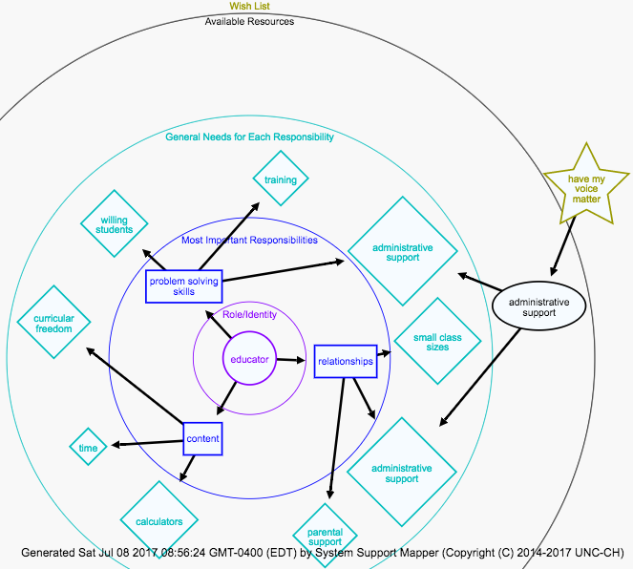

Figure 1: a simple System Support Map from the Connecticut “Mental Health in Schools” study.

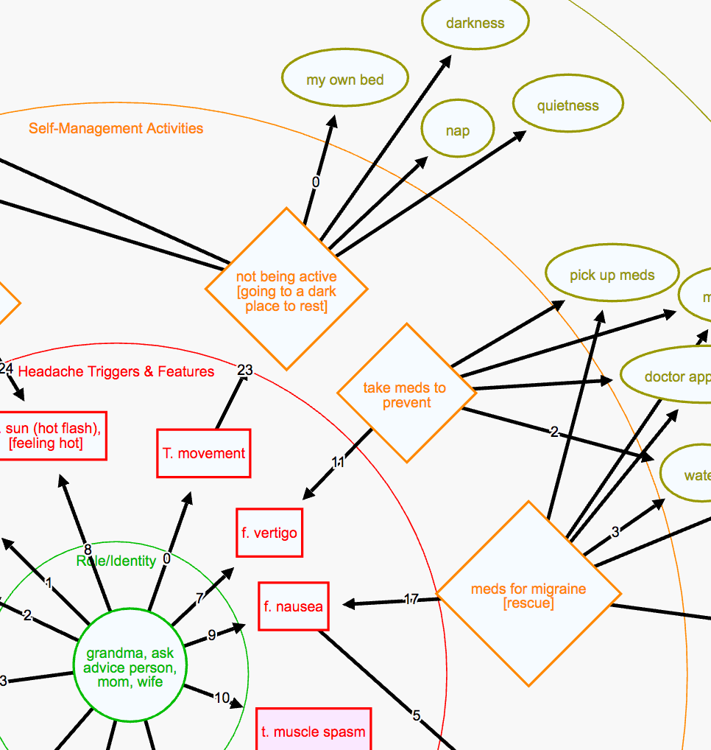

Figure 2: a fragment of an SSM from the Duke study of migraines in women. This set of maps was created with a system support mapper website tuned to the needs of this particular study.

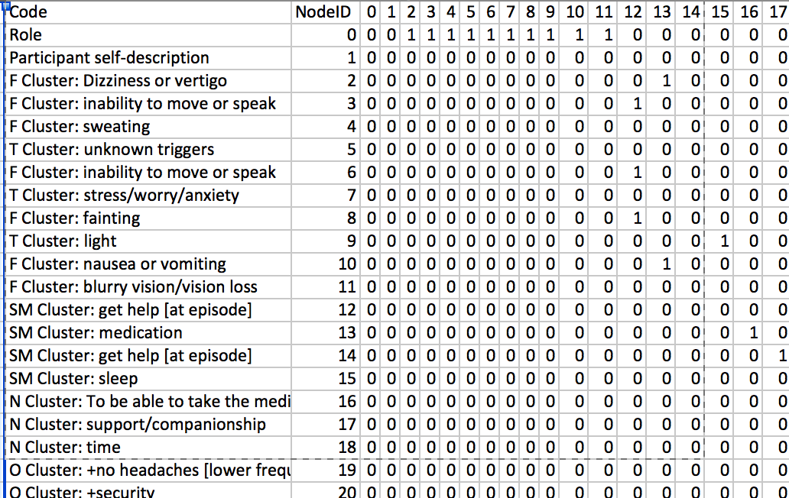

Figure 3: Screenshot of a small part of a Coded Binary Link Matrix. The codes on the left were assigned for each node using the interactive *sort* website. The matrix on the right shows whether any two nodes, and in consequence their associated codes, are connected in the originating SSM.

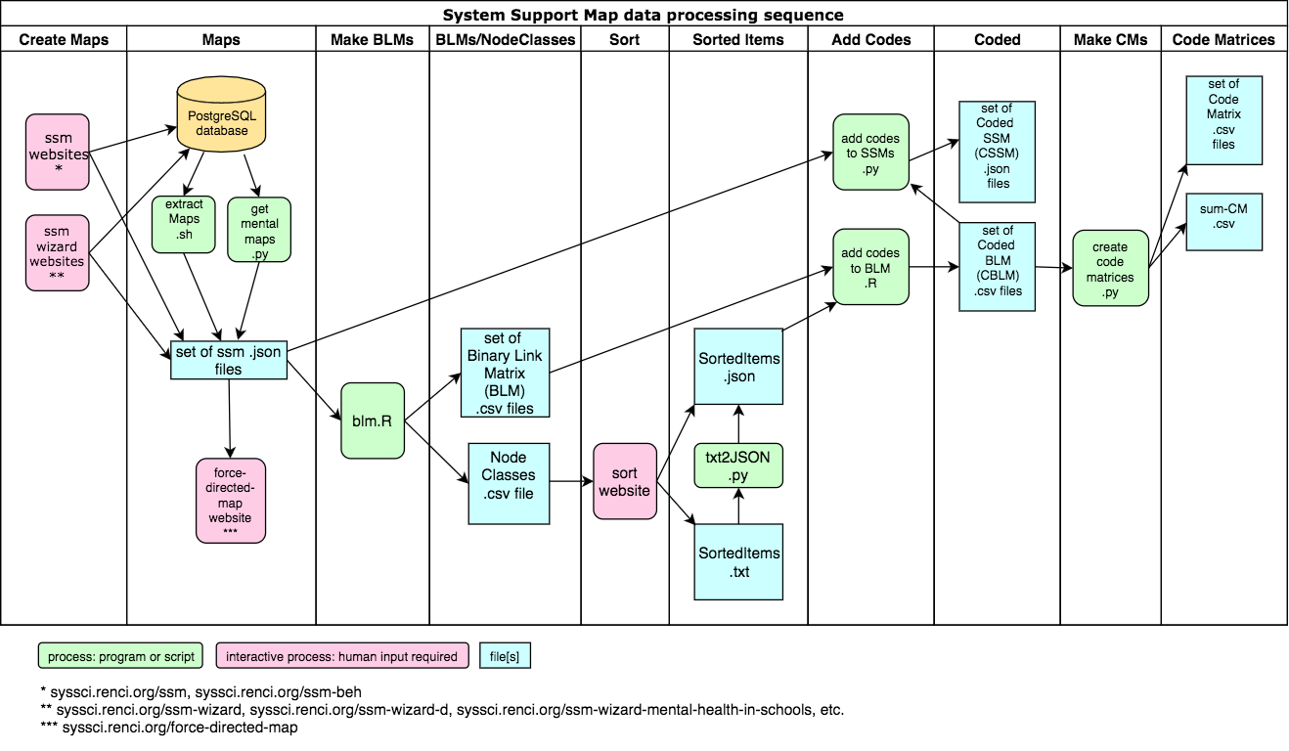

Figure 4: Outline of the processing sequence for SSMs.